Date | Category | Topic | Stamped/Signedby
4 May 2022 | 11 | Oxygen administration | 
5 May 2022 | 11 | Traction split
6 May 2022 | 10 | Management of an unconscious patient, CPR and use of an AED
12 August 2022 | 3 | Types of wounds and management, CPR | 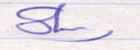
11 November 2022 | 8 | Spinal Immobilization | 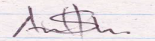
21 December 2022 | 8 | ECG Readings | 

